Using the WebBrowser Control

Welcome to this web browser control tutorial! In this tutorial you will learn:

- How to Navigate, Stop, Search, Refresh, Go Home, Go Backward, and Go Forward with the Microsoft Web Browser Control

- How to disable most pop ups, script errors, and debug errors

- How to change the size of text in the web browser

- How to create a search toolbar

- Other webbrowser tips and tricks

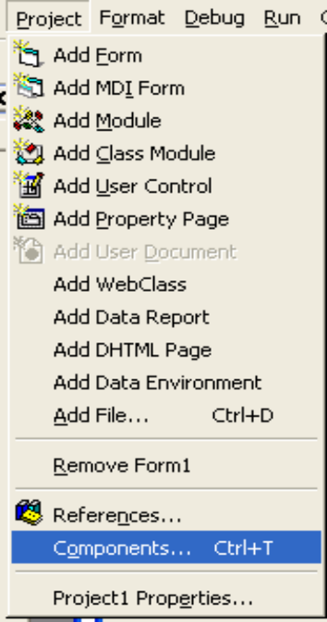
To use the webbrowser control, we will need shdocvw.dll. Most people have this already. If you don’t, you can get it at: http://www.dll-files.com/dllindex/dll-files.shtml?shdocvw. Once you’ve done that, open a new project in Visual Basic. On the Project menu, select Components (or press Ctrl + T). Select Microsoft Internet Controls from the list.
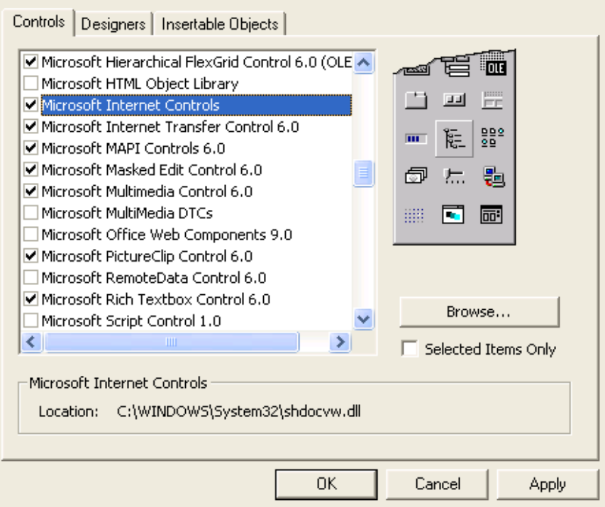
Once you click OK, you will see a globe icon appear in the toolbox.


Now that we’ve added the web browser control, we can begin. Select the globe icon from the toolbox. Draw a web browser control on the form. You can add buttons, toolbars, or some kind of user - interacting control to complete the following commands:

Navigate

You’ll need a text box or text input for this. The code is: (assuming Text1 is our URL source and Command1 is our “go” button)

Private Sub Command1_Click()

WebBrowser1.Navigate Text1.Text

End Sub

That tells the browser to simply navigate to the URL in Text1. If the URL is invalid, the browser will display the famous message: This Page Cannot Be Displayed...

Back

For this one, all you need is a button of some sort. In this snippet, Command2 is our button.

Private Sub Command1_Click()

WebBrowser1.GoBack

End Sub

The web browser seems so simple now, doesn’t it? This is just moving one page back in history.
Oh, if we could all do that...

Forward

This is just the same as back, only assuming our special button this time is Command3.

Private Sub Command3_Click()

WebBrowser1.GoForward

End Sub

This is moving one page forward in history. This button isn’t used that often, actually...

Stop

Same old stuff here. Nothing ever changes, really. The lucky button this time is Command4.

Private Sub Command4_Click()

WebBrowser1.Stop

End Sub

Stop. No more loading. That’s what will happen when you press this. (Duh)

Refresh

Just a button. Command5...

Private Sub Command5_Click()

WebBrowser1.Refresh

End Sub

Kinda like at work, huh? Stop, do it all over again. Refresh. It looks the same as last time anyway. Nothing special about the refresh button.

Go Home

This function involves the complex clicking of a button called Command6...

Private Sub Command6_Click()

WebBrowser1.GoHome

End Sub

Go home kid! This takes you to your home page.

Go Search

Our final part of step one! This code is assuming the winning button for today is Command7.

Private Sub Command7_Click()

WebBrowser1.GoSearch

End Sub

Go search kid! Never mind. This button takes you to your search page. Bet you never knew you had one!

That concludes section one of my tutorial. Only a dozen of you probably read that part and are reading this now. Oh well. There are beginners on the face of the planet that I need to feed. Let’s proceed.

Die Nasty Errors!

Most Internet browsers block script errors. You will learn how to block both. Since the Silent property of the web browser doesn’t serve it’s proper function, we have to force it to. Create a timer and type, copy and paste, or use other clever transferring methods to make this code appear magically in the Timer1_Timer event:

Private Sub Timer1_Timer()

WebBrowser1.Silent = True

Timer1.Enabled = False

End Sub

Set Timer1’s interval property to 5 and you’re done! Now no nasty script errors will come upon you and your wonderful world of web browsing!

Note: this may block other dialog boxes too, sometimes causing your browser to crash

Die Popup Windows!

The WebBrowser Control has a wonderful event called NewWindow2 that allows you to control popups. If you make a method of allowing the user to choose whether or not to block popups, you can use this code:

Private Sub WebBrowser1_NewWindow2(ppDisp As Object, Cancel as Boolean)

Dim NewBrowser As New Form1

If BockPopups = True Then
Cancel = True
Exit Sub
End If

NewBrowser.Show
ppDisp = NewBrowser.WebBrowser1.Object

End Sub

Whoa. This code is assuming that the main form is Form1 and you have created a boolean variable that the user can set to block popups. If the variable is true, then it cancels the browser’s request to open a new window. If it is false, then it will open a new window with the popup loading in your webbrowser control.

That is the end of section two. Yay. Let’s move on.

Changing The Size of Text

If you preference your text in a web browser big, or if the creators of a web site print their stuff too small, this code is for you! This just simply changes the size of viewing text, and it doesn’t work on all text. Here it is:

Private Sub setTextSize(TextSize As Integer)

Dim range As Variant

range = CLng(TextSize)

WebBrowser1.ExecWB OLECMDID_ZOOM, OLECMDEXECOPT_DONTPROMPTUSER, range, Null

End Sub

This code sets everything using that code. You just have to call it. Here’s an example:

Public Sub Command8_Click()

Select Case Text2.Text

Case “0” ‘Smallest
SetTextSize(0)

Case “1” ‘Small
SetTextSize(1)

Case “2” ‘Normal
SetTextSize(2)

Case “3” ‘Large
SetTextSize(3)
Case “4” ‘Largest
SetTextSize(4)

End Select

End Sub

Wonderful. Done. Next section. Here we go.

Making Your Very Own Google Bar

You can create a simple search toolbar with the search engines Yahoo, Google, MSN, and others. Create a text input box of some sort and a dropdown box with the search engine you wish to have in it. Here is an example of when a “go” button is clicked on this toolbar:

On Error Resume Next

Dim searchsite, searchstring As String

searchsite = Combo1.Text
searchstring = Text3.Text

If searchsite = "Yahoo!" Then
WebBrowser1.Navigate "http://search.yahoo.com/search?p=" & searchstring & "&ei=UTF-8&fr=FP-tab-web-t&fl=0&x=wrt"

ElseIf searchsite = "Google" Then
WebBrowser1.Navigate "http://www.google.com/search?hl=en&q=" & searchstring

ElseIf searchsite = "MSN" Then
WebBrowser1.Navigate "http://search.msn.com/results.aspx?FORM=MSNH&q=" & searchstring

End If

A simple way to do this is to go to the search engine you want to add, type some nonsense in the search box, and click search. Look at the URL of the page when it is done loading and locate the text you searched for. That is where the searchstring variable goes. Copy and paste the URL to VB and replace your search text with – “ & searchstring & “. That is it. Search toolbar done.

Other Tips and Tricks

Look through the events and properties of the webbrowser control. You may learn something new. That’s what I did. I experimented and learned new things. Oh, that’s great ‘Other Tips & Tricks’… I may as well put, ‘Something to do when you’re bored,’ or something.

That’s the end of my wonderful tutorial. Hope you liked it. Vote if you want…

